create table student8(

regno varchar(30),

name varchar(30),

major varchar(30),

bdate date,

primary key(regno));

create table course(

course_no int,

cname varchar(10),

dept varchar(30),

primary key(course_no));

create table enroll(

regno varchar(30),

course_no int,

sem int,

marks int,

primary key(regno,course_no),

foreign key(regno) references student8(regno) on delete cascade,

foreign key(course_no) references course(course_no) on delete cascade);

create table text(

book_isbn int,

book_title varchar(50),

publisher varchar(50),

author varchar(50),

primary key(book_isbn));

create table book_adoption(

course_no int,

sem int,

book_isbn int,

primary key(course_no,book_isbn),

foreign key(course_no) references course(course_no) on delete cascade,

foreign key(book_isbn) references text(book_isbn) on delete cascade);

INSERT INTO student8 VALUES ('1bm18cs001','a','sr','09-DEC-17');

INSERT INTO student8 VALUES ('1bm18cs002','b','sr','01-JUN-17');

INSERT INTO student8 VALUES ('1bm18cs003','c','sr','27-NOV-93');

INSERT INTO student8 VALUES ('1bm18cs004','d','sr','13-APR-93');

INSERT INTO student8 VALUES ('1bm18cs005','e','jr','24-AUG-94');

INSERT INTO course VALUES (111,'OS','CSE');

INSERT INTO course VALUES (112,'EC','CSE');

INSERT INTO course VALUES (113,'SS','ISE');

INSERT INTO course VALUES (114,'DBMS','CSE');

INSERT INTO course VALUES (115,'SIGNALS','ECE');

INSERT INTO text VALUES (10,'DATABASE SYSTEMS','PEARSON','SCHIELD');

INSERT INTO text VALUES (900,'OPERATING SYS','PEARSON','LELAND');

INSERT INTO text VALUES (901,'CIRCUITS','HALL INDIA','BOB');

INSERT INTO text VALUES (902,'SYSTEM SOFTWARE','PETERSON','JACOB');

INSERT INTO text VALUES (903,'SCHEDULING','PEARSON','PATIL');

INSERT INTO text VALUES (904,'DATABASE SYSTEMS','PEARSON','JACOB');

INSERT INTO text VALUES (905,'DATABASE MANAGER','PEARSON','BOB');

INSERT INTO text VALUES (906,'SIGNALS','HALL INDIA','SUMIT');

INSERT INTO enroll VALUES ('1bm18cs001',115,3,100);

INSERT INTO enroll VALUES('1bm18cs002',114,5,100);

INSERT INTO enroll VALUES('1bm18cs003',113,5,100);

INSERT INTO enroll VALUES('1bm18cs004',111,5,100);

INSERT INTO enroll VALUES('1bm18cs005',112,3,100);

INSERT INTO book_adoption VALUES (111,5,900);

INSERT INTO book_adoption VALUES (111,5,903);

INSERT INTO book_adoption VALUES (111,5,904);

INSERT INTO book_adoption VALUES (112,3,901);

INSERT INTO book_adoption VALUES (113,3,10);

INSERT INTO book_adoption VALUES (114,5,905);

INSERT INTO book_adoption VALUES (113,5,902);

INSERT INTO book_adoption VALUES (115,3,906);

INSERT INTO book_adoption VALUES (112,5,906);

select * from student8;

select * from course;

select * from text;

select * from enroll;

select * from book_adoption;

SELECT c.course_no,t.book_isbn,t.book_title

FROM course c,book_adoption ba,text t

WHERE c.course_no=ba.course_no

AND ba.book_isbn=t.book_isbn

AND c.dept='CSE'

AND 2<( SELECT COUNT(book_isbn)

FROM book_adoption b

WHERE c.course_no=b.course_no)

ORDER BY t.book_title;

SELECT DISTINCT c.dept

FROM course c

WHERE c.dept IN

( SELECT c.dept

FROM course c,book_adoption b,text t

WHERE c.course_no=b.course_no

AND t.book_isbn=b.book_isbn

AND t.publisher='PEARSON')

AND c.dept IN

(SELECT c.dept

FROM course c,book_adoption b,text t

WHERE c.course_no=b.course_no

AND t.book_isbn=b.book_isbn

AND t.publisher != 'PEARSON');

Student

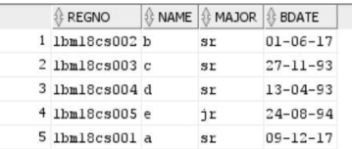

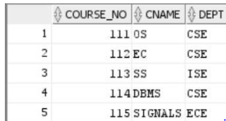course

Enroll

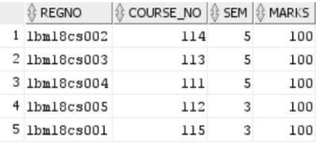

Text

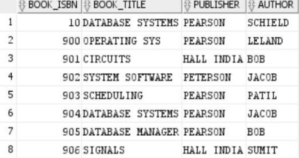

Book Adoption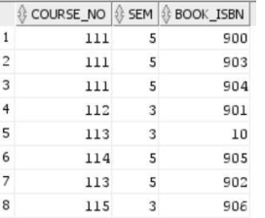

QUERY RESULTS:

